Gustavo Sousa
J R . F U L L S T A C K D E V E L O P E R

Rua Quinta dos Apóstolos. Ferreiros, Braga

ABOUT ME
Hello, my name is Gustavo Felipe Marques de Sousa, I'm 23 years old and I have a degree in Computer Engineering. From an early age, I have always been fascinated by technology and programming, which led me to pursue this career.
Although I don't have much hands-on experience in the field of full stack development yet, I am extremely motivated and willing to learn. Recently, I started studying React and Django to expand my knowledge.

SKILLS
Python
Javascript

WORK EXPERIENCE
Trainee / Intern SEDECTI

2022-2023

HTML & CSS3
Django Flask MySQL
Data analysis
Evaluation and manipulation of information within the scope of data design.
Participation in events promoted by the innovation ecosystem.
Contribution to the design of new concepts and technological initiatives.

EXPERTIZE
Communication
Ability to Work Under Pressure Time Management
Adaptability Decision Making Fast Learn
Infrastructure Assistant
Polonorte Serviços Empresarias LTDA

Helpdesk
Network and Infrastructure Maintenance. Computer and network maintenance

EDUCATION

2021-2022

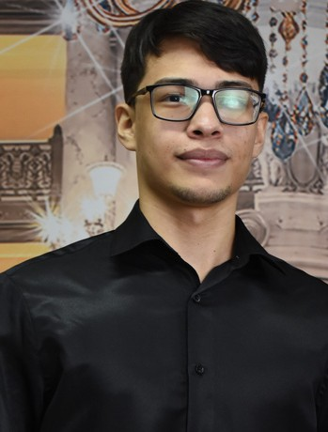

LANGUAGES

85% 100%
English Portuguese
BACHELOR IN COMPUTER ENGINEER
Fametro | 2018-2024

CONTACTS
sousa.gfm@gmail.com https://gustavofms.github.io/portfolio-gustavo-felipe/
+351 912 708 100

